**Software Development Lab – II [15B17CI271]**

**Assignment Sheet**

**Week 4**

**Q1.**

#include<iostream>

using namespace std;

class wall

{

float *length;

float height;

public:

wall(float l,float h)

{

*length=l;

height=h;

}

wall()

{

length=new float;

}

wall(wall &w)

{

length=w.length;

height=w.height;

}

float area()

{

return *length*height;

}

};

int main()

{

float l,hei,AREA;

cout<<"Enter the length of the wall :";

cin>>l;

cout<<"Enter the height of the wall : ";

cin>>hei;

wall w1(l,hei);

cout<<"Parameterized constructor calling ......"<<endl; AREA=w1.area();

cout<<endl<<endl<<"The area is :"<<AREA;

wall w2(w1);

cout<<endl<<endl<<"Copy constructor calling .........."<<endl; AREA=w2.area();

cout<<endl<<"The area is :"<<AREA;

}

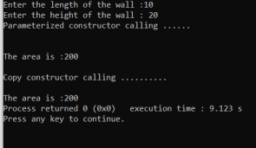

**Q2.**

#include<string.h>

#include<iostream>

using namespace std;

class String

{

char *s;

int length;

public:

String()

{

length=50;

s=new char[length];

strcpy(s,"unknown");

}

String(String &s1)

{

length=s1.length;

s=new char[length+1];

strcpy(s1.s,s);

}

void display()

{

cout<<endl<<"Length is : "<<length<<endl; cout<<"The String is : "<<s;

}

~String()

{

delete [] s;

cout<<"Destructor called ......."<<endl;

}

};

int main()

{

String str;

cout<<endl<<"Constructor calling ......";

str.display();

cout<<endl<<"Copy constructor calling .....";

String str1(str);

str1.display();

}

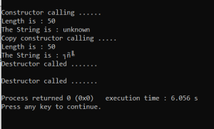

**Q3.**

Printing through object name: Value of X: 10

Value of Y: 20

Printing through class name: Value of X: 10

Value of Y: 20

**Q4.**

#include<iostream>

using namespace std;

class xyz;

class abc

{

int numa;

public:

abc ()

{

numa=101;

}

friend xyz;

};

class xyz

{

int number;

public:

xyz()

{

number=202;

}

abc A;

void sum()

{

cout<<"The sum of the nos is : "<< A.numa+number ; }

};

int main()

{

abc A;

xyz B;

B.sum();

}

